NYGATS Training: NYGATS Account Registration

Introduction:
This training document will walk the user through the steps needed to register an account in the New York Generation Attribute Tracking System (NYGATS). Please refer to the NYGATS Operating Rules for additional information on all rules governing the registration and use of your NYGATS Account. Any Questions about the registration of an account or the use of NYGATS can be directed to:
NYGATS Administrator
NYGATS@apx.com
408-643-0617

Training:
Step 1: Navigate to the NYGATS Informational Site: http://www.nyserda.ny.gov/nygats
Step 2: Select the ‘Registration for New Users’ button located on the right hand side of the screen. Selecting the ‘Registration for New Users’ button will redirect the user to the NYGATS Account Registration Screen where the user will fill out the NYGATS Participant Account Holder Agreement.
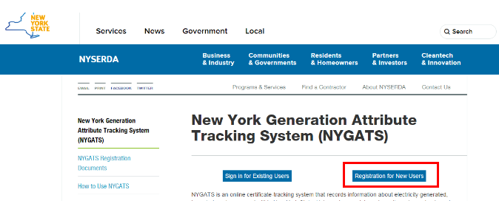

Step 3: From the NYGATS Participant Account Holder Agreement screen, review the registration steps listed on the screen outlining the entire Account Registration process.
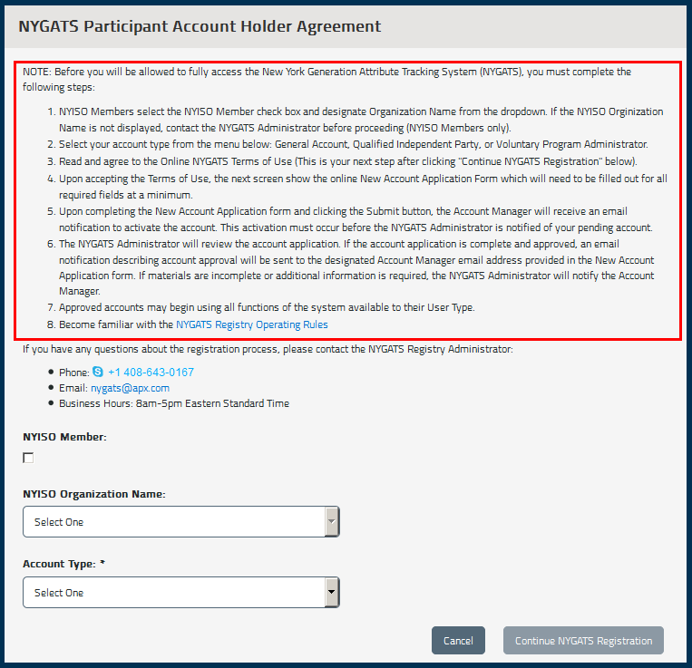
Step 4: NYISO Members select the ‘NYISO Member’ check box and designate ‘Organization Name’ from the dropdown (NYISO Members only). If the NYISO Organization Name is not displayed, contact the NYGATS Administrator before proceeding.
From the ‘Account Type’ menu, non-NYISO Account Holders can select one of the following options: General Account, Qualified Independent Party, or Voluntary Program Administrator. NYISO Members will have the ‘Account Type’ designated for them. Select the ‘Continue NYGATS Registration’ button located at the bottom of the screen.

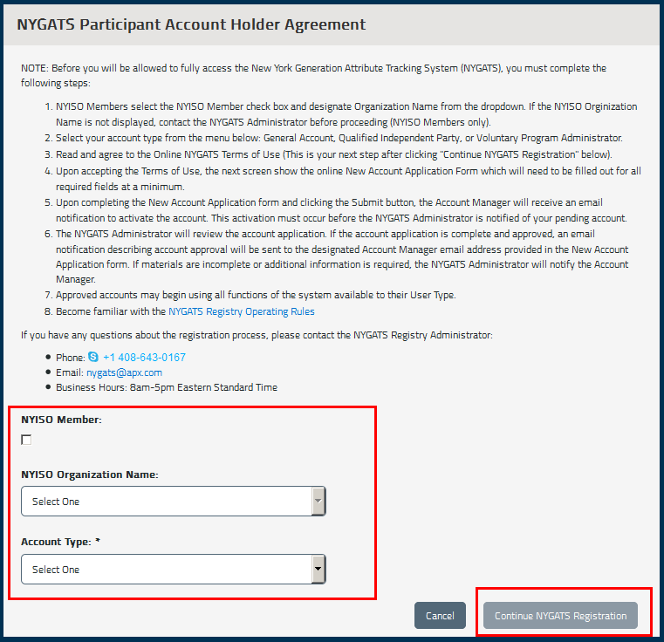

Step 5: After clicking the ‘Continue NYGATS Registration’ button, the user will be directed to read and agree to the Online NYGATS Terms of Use. Select the ‘I Agree’ Checkbox at the bottom of the Terms of Use and enter the Name and Title of the account representative. After selecting the ‘Agree’ button, the Name, Title, IP Address and timestamp will be recorded as the digital acceptance of the Terms of Use.
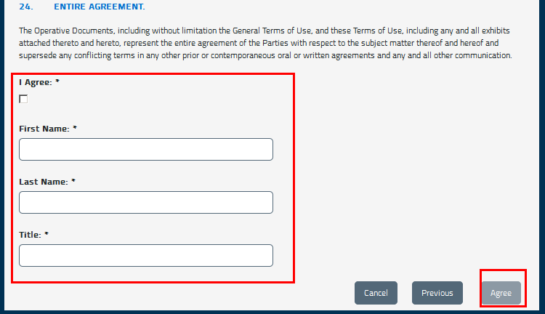
Step 6: Upon accepting the Terms of Use, the next screen shows the online New Account Application Form (Company Information, Account Manager Information and Login Information) which will need to be filled out for all required fields at a minimum. Pressing the ‘Submit’ button will initiate an email to the email address associated with the account to authenticate the registered email address and login information. The NYGATS Administrator will review the account application. If the account application is complete and approved, an email notification describing account approval will be sent to the designated Account Manager’s email address provided in the New Account Application form. If materials are incomplete or additional information is required, the NYGATS Administrator will notify the Account Manager.
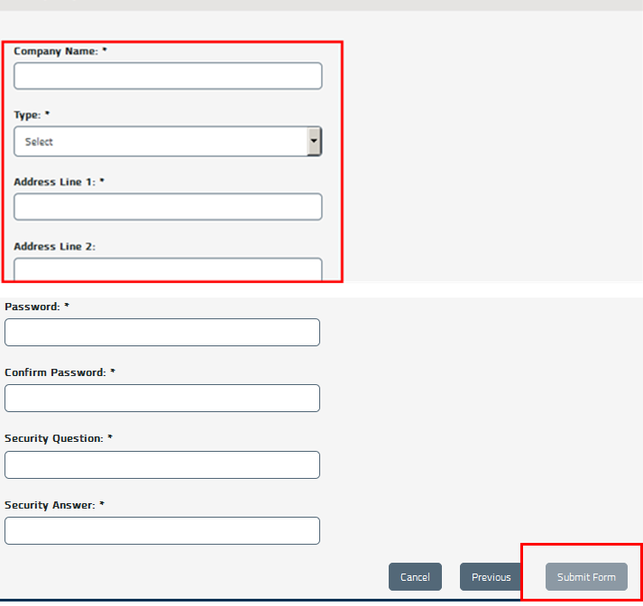

Step 7: Once the NYGATS Administrator Approves the NYGATS Account Registration, the Account Holder can login to NYGATS by navigating to the NYGATS Informational Site: http://www.nyserda.ny.gov/nygats and selecting the ‘Sign in for Existing Users’ button located on the right hand side of the screen. Selecting the ‘Sign in for Existing Users’ button will redirect the user to the NYGATS Account Login Screen where the user can enter their Username and Password to access their account.
